**HTML-PHP Connection with MySQL DB using XAMPP**

**Create a MySQL Database on XAMPP server named “devops1”. Create a table called ‘register’ with the following fields:**

* **Sapid**
* **Name**
* **Branch**
* **Gender**
* **Mobile number**
* **Email**

1. **Create an HTML form for registration of students and create a PHP script to submit the registration details in the database.**
2. **Create a PHP script to take the name, sapid and branch of all students and display in tabular fashion.**
3. **Create an HTML Login Page using Sap ID and Name of the student and allow/deny access by matching his/her credentials using PHP script.**

**Creation of Database “devops1”**

* Open the XAMPP Control Panel and launch the modules **Apache** and **MySQL.**
* On the browser, go the address **localhost/phpmyadmin** to see the MySQL console.

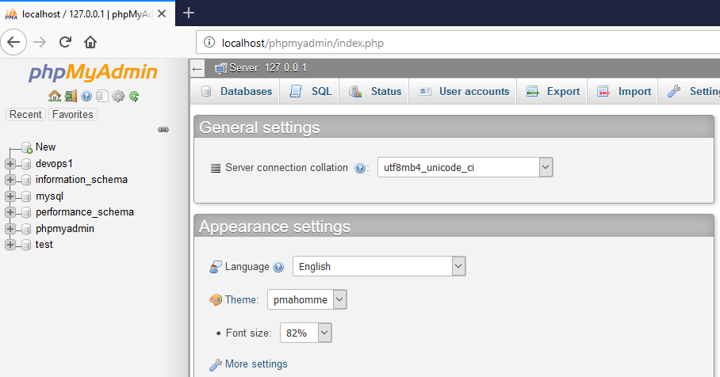

* On the top bar, Click on **Databases.** A list of Databases present on the localhost server opens up
* In the **Create Database** portion, enter name as **devops1** and set the database type as **collation.**Click on **Create** button.
* The database is created and shown on the sidebar, Click on it and select the **new** option from dropdown list to create a table.

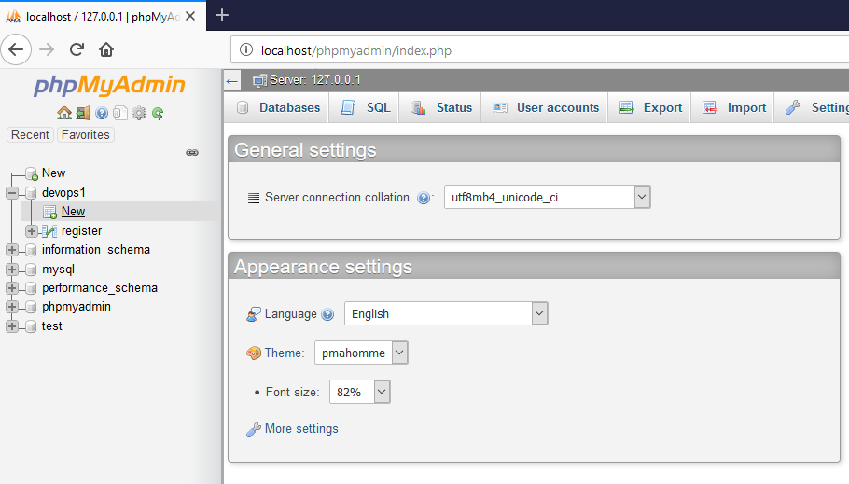

* Enter **Table name** as “register” and **number of attributes** and click on **Go.**

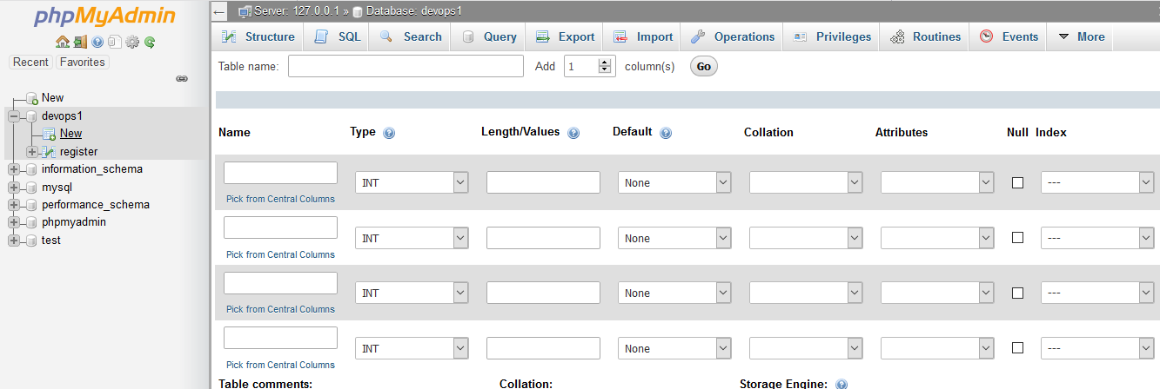

Enter the various attribute details:

* Sapid : Int
* Name: Text
* Gender: Text
* Branch: Text
* Mobile Number: Integer
* Email: Varchar (20)

Click on Create to create the Table “register”.

1. Registration Form Creation

**HTML File: register2.html**

<html>

<style>

body {background-color:lightblue;}

</style>

<h2 style="text-align:center;">Student Registration Form</h2>

<form action="register2.php" method="post">

<center>

<table>

<tr>

<td>SAP ID</td>

<td><input type="text" name="sapid"></td>

</tr>

<tr>

<td>Name</td>

<td><input type="text" name="name"></td>

</tr>

<tr>

<td>Branch</td>

<td>

<select name="branch">

<option value="DevOps">DevOps</option>

<option value="Big Data">Big Data</option>

<option value="CCVT">CCVT</option>

</select>

</td>

</tr>

<tr>

<td>Gender</td>

<td>

<input type="radio" name="gen" value="Male">Male

<input type="radio" name="gen" value="Female">Female

</td>

</tr>

<tr>

<td>Mobile Number</td>

<td><input type="text" name="mno"></td>

</tr>

<tr>

<td>Email</td>

<td><input type="text" name="email"></td>

</tr>

<tr>

<td><input type="submit" value="Submit!"></td>

</tr>

</table>

</center>

</form>

</html>

**Output: Execution on-> localhost/register2.html**

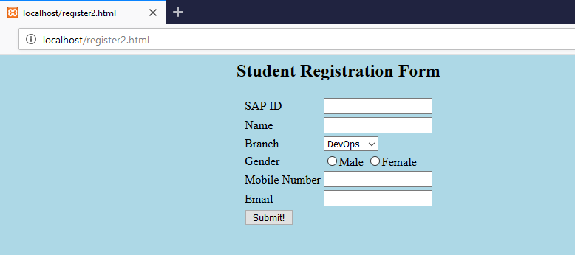

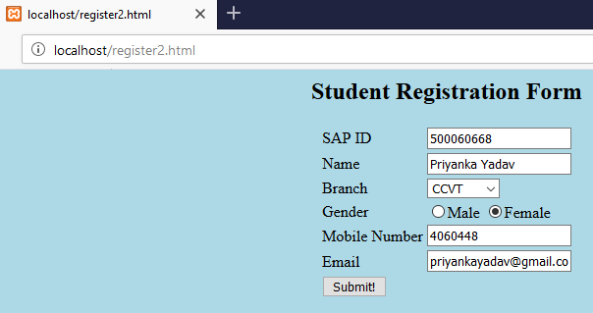

**PHP file: register2.php**

<?php

$i=$_POST["sapid"];

$n=$_POST["name"];

$b=$_POST["branch"];

$g=$_POST["sapid"];

$m=$_POST["mno"];

$e=$_POST["email"];

$con=mysqli_connect("localhost","root","","devops1");

$sql="insert into register values ($i,'$n','$b','$g','$m','$e')";

mysqli_query($con,$sql);

echo "Successfully Registered";

?>

**Output:**

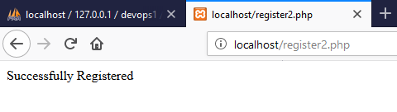

**Output: Record in Database**

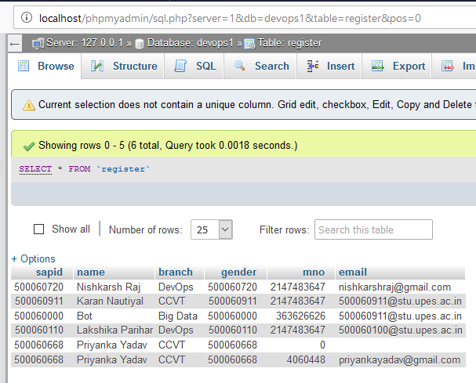

1. Select name, sapid and branch of all students from the database and show it on HTML file

**PHP file: select.php**

<?php

$con=mysqli_connect("localhost","root","","devops1");

$sql="select sapid,name,branch from register";

$res=mysqli_query($con,$sql);

echo "<table border='2'><tr><th>SAP ID</th><th>Name</th><th>Branch</th></tr>";

while($row=mysqli_fetch_array($res))

{

echo "<tr><td>".$row["sapid"]."</td><td>".$row["name"]."</td><td>".$row["branch"]."</td></tr>";

}

echo "</table>";

?>

**Output: Execution on-> localhost/select.php**

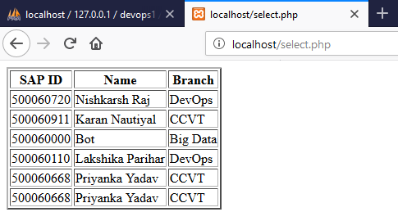

1. **Creation of a Login page in HTML and PHP script to validate the login.**

**HTML Code: login.html**

<html>

<style>

body {background-color:lightblue;}

h2 {text-align:center;}

</style>

<h2>Login Page</h2>

<br>

<form action="login.php" method="post">

<center>

<table>

<tr>

<td>SAP ID</td>

<td><input type="text" name="sapid"></td>

</tr>

<tr>

<td>Name</td>

<td><input type="text" name="name"></td>

</tr>

<tr>

<td><input type="submit" value="Login"></td>

</tr>

</table>

</center>

</form>

</html>

**PHP file:** **login.php**

<?php

$i=$_POST["sapid"];

$n=$_POST["name"];

$con=mysqli_connect("localhost","root","","devops1");

$sql="select sapid,name from register";

$res=mysqli_query($con,$sql);

$p=0;

while($row=mysqli_fetch_array($res))

{

if(($row["name"]==$n)&&($row["sapid"]==$i))

{

$p=1;

}

}

if($p==1)

{

echo "Login Successful";

}

else

{

echo "Wrong credentials";

}

?>

**Output=>Successful login:**

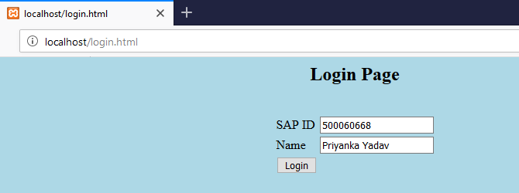



**Output=> Unsuccessful Login:**



